|  |
| --- |
| Surveyor-General of Victoria Practice Directives  September 2014  Edition 3 |

|  |
| --- |
|  |

|  |  |  |  |  |  |  |  |  |  |  |  |  |
| --- | --- | --- | --- | --- | --- | --- | --- | --- | --- | --- | --- | --- |
| Cover photo courtesy of Raymund Earls, Mount Oberon Trigonometrical Station, Wilsons Promontory National Park  ISBN 1 74152 650 7  Version 4.0  Office of Surveyor-General Victoria Land Victoria Department of Environment, Land, Water and Planning 570 Bourke Street Melbourne VIC 3000 Phone: (03) 8636 2525 Fax: (03) 8636 2776 Email: [surveyor.general@delwp.vic.gov.au](mailto:surveyor.general@delwp.vic.gov.au) Web: www.delwp.vic.gov.au>Property and land titles>Surveying  Revision History   |  |  |  |  | | --- | --- | --- | --- | | **Edition** | **Commence** | **Summary of revisions** | **Section** | | 2 | 14 June 2015 | Amendments consequential to the making of the Surveying (Cadastral Surveys) Regulations 2015 | 2.2, 2.4, 4, 6.3.3,  Appendices 1, 2 and 3 | | 3 | 1 July 2016 | Replacement of non-survey guidelines with guidelines for survey documents required when lodging a plan of subdivision or consolidation | Appendix 3 |   Logo© The State of Victoria Department of Environment, Land, Water and Planning 2015    This work is licensed under a Creative Commons Attribution 4.0 Australia licence. You are free to re-use the work under that licence, on the condition that you credit the State of Victoria as author. The licence does not apply to any images, photographs or branding, including the Victorian Coat of Arms, the Victorian Government logo and the Department of Environment, Land, Water and Planning logo. To view a copy of this licence, visit [http://creativecommons.org/licenses/by/4.0](http://creativecommons.org/licenses/by/3.0/au/deed.en)/  **Accessibility**  If you would like to receive this publication in an alternative format, please telephone the DELWP Customer Service Centre on 136186, email [customer.service@delwp.vic.gov.au](mailto:customer.service@delwp.vic.gov.au) or via the National Relay Service on 133 677 [www.relayservice.com.au](http://www.relayservice.com.au).  **Disclaimer**  This publication may be of assistance to you but the State of Victoria and its employees do not guarantee that the publication is without flaw of any kind or is wholly appropriate for your particular purposes and therefore disclaims all liability for any error, loss or other consequence which may arise from you relying on any information in this publication. |

Contents

1 Practice Directives 3

1.1 Purpose of Practice Directives 3

1.2 Disclaimer 3

1.3 Role of the Surveyor-General of Victoria 3

1.4 Compliance and Survey Audit Program 3

2 Connection of cadastral surveys to MGA94 and the Survey Control Network 4

2.1 General comments 4

2.2 Specific requirements for connection to the Survey Control Network 5

2.2.1 ‘Large’ land subdivision creating 10 lots or more 5

2.2.2 ‘Small’ land subdivisions creating less than 10 lots, building subdivisions, application surveys under the *Transfer of Land Act 1958*, boundary plan surveys and Crown surveys 5

2.3 MGA94 datum derived by GNSS measurement 6

2.3.1 General 6

2.3.2 Connection to datum 6

2.3.3 GNSS measurement quality and site specific error sources 7

2.3.4 Maximising RTK positioning quality 7

2.3.5 Verifying GNSS measurements 7

2.3.6 Deriving bearing and distance from RTK positioning 7

2.3.7 Recommended GNSS measurement and verification procedures 8

2.3.8 Recording and submission of GNSS observations 9

2.4 Re-establishment surveys and partial surveys 9

2.5 Permanent Marks 10

2.6 Primary Cadastral Marks 10

2.7 Recording connection information 11

2.7.1 Recording field observations 11

2.7.2 Recording the map projection and zone 11

3 Marking of lot boundaries 11

4 Records of a re-establishment survey 12

5 Report by the licensed surveyor 13

5.1 Report inclusions 13

6 Abstracts of field records 14

6.1 General advice 14

6.1.1 The purpose for preparing an abstract of field records 14

6.1.2 Life of a survey and abstract of field records 14

6.2 Land Registration Services requirements 15

6.2.1 Requirement for an abstract of field records 15

6.2.2 Subdivision of ‘Super-Lots’ and subsequent stages of an ’estate type’ Master Plan 15

6.3 Format of the abstract of field records 16

6.3.1 If conventional traversing techniques have been employed 16

6.3.2 If non-conventional measurement techniques have been employed 16

6.3.3 Postponement of placement of marks and/or lodgement of supplementary abstract of field records 16

7 EDM calibration 17

7.1 Meeting EDM standards requirements 17

7.2 Recording and reporting on EDM comparisons 17

8 Precision of dimensions on plans of cadastral surveys and abstracts of field records 18

9 General advice 19

9.1 Use of GNSS for cadastral surveying 19

9.2 Surveyor-General consent to Crown land boundary determinations 19

9.3 State border determinations 19

9.4 Consideration of the width of roads 20

Appendix 1 – Example of abstract of field records for conventional traversing techniques 21

Appendix 2 – Example of alternative (non-conventional) abstract of field records 22

Appendix 3 – Survey documents required when lodging a plan of subdivision or consolidation 24

Exemptions to providing an abstract of field records 24

Partial surveys 24

Non-survey guidelines for plans lodged under Section 32 of the *Subdivision Act 1988* 24

Appendix 4 – Land Victoria guidelines for estate subdivisions 26

Supplementary Abstract of Field Records 26

Licensed surveyor’s report 26

Examples of licensed surveyor’s reports 27

1 Practice Directives

These practice directives concern the connection of cadastral surveys to the Geodetic Survey Control Network (SCN), the preparation of reports and abstracts of field records by a licensed surveyor and the requirements for estate subdivisions. The following sections detail the requirements of surveyors in fulfilling legislative obligations.

Current regulations are available for download from the Government’s Victorian Law Today website at www.legislation.vic.gov.au.

1.1 Purpose of Practice Directives

Under the provisions of the *Surveying Act 2004*, two of the functions of the Surveyor-General are to ‘set and monitor standards for surveying and survey information’ and ‘monitor surveying matters affecting the Victorian cadastral system’. In accordance with these functions, the Surveyor-General of Victoria issues Practice Directives to provide advice to licensed surveyors in the interpretation of relevant aspects of the acts and regulations relating to surveying.

*The Surveyor-General of Victoria Practice Directives – September 2014* are effective from 1 September 2014 and replace the *Surveyor-General of Victoria Practice Directives – January 2011* and the interim Requirements for Connection to MGA94 – November 2013.

Comments on these practice directives, and other matters relating to cadastral surveying, are welcome from surveyors. All enquiries can be directed to:

David R. Boyle  
Deputy Surveyor-General of Victoria  
570 Bourke Street  
Melbourne, VIC 3000  
Phone: (03) 8636 2525  
Fax: (03) 8636 2776  
Email: david.r.boyle@delwp.vic.gov.au

1.2 Disclaimer

These practice directives offer guidance to cadastral surveyors on the interpretation of the relative legislative requirements and processes they may apply in carrying out their professional roles; but, do not override a surveyor’s responsibility to exercise professional judgement. These practice directives are to be viewed and adopted in conjunction with the relevant legislation, best practice guidelines (as available) and general good practice principles and procedures.

1.3 Role of the Surveyor-General of Victoria

The Surveyor-General of Victoria is the primary government authority on cadastral surveying and maintenance of the integrity of the cadastre. The roles and responsibilities of the Surveyor-General are prescribed under a diverse range of acts and regulations of parliament.

1.4 Compliance and Survey Audit Program

The most visible component of the monitoring of the standard of surveying in Victoria is provided by the Survey Audit Program, undertaken by the Office of Surveyor-General Victoria (OSGV) on surveys lodged at Land Victoria. Through this program the Surveyor-General is able to gauge practitioners’ compliance with the regulations, practice directives and guidelines for best practice, and contribute to any collective or individual rectification/adjustment processes required. OSGV currently aims to audit every practising licensed surveyor at least once every three years.

OSGV survey auditors use a ‘Survey Audit Checklist’ covering the abstract of field records, re-establishment, connection to MGA94, the report by a licensed surveyor and elements of the field survey. The Survey Audit Program Checklist is available online from www.delwp.vic.gov.au>Property and land titles>Surveying>Advice and guidelines for surveyors>Survey Audit Program.

The checklist is provided as an option for individual members of the profession to assist in maintaining the quality of surveys lodged at Land Victoria.

Non-conformance with aspects of the survey and/or documentation as indicated by items on the survey audit and plan exam checklists will result in the associated dealing lodged at Land Victoria not being registered until issues are rectified to the satisfaction of Land Registration Services and the Surveyor-General.

In addition, checklist items are categorised into serious and non-serious non-conformances, as classified in Categories of Audit Non-Conformances, available from the web link above. An ‘unsatisfactory’ survey audit result will occur when one or more serious non-conformances and/or 10 or more non-serious non-conformances are identified.

Surveyors who receive two consecutive unsatisfactory survey audit results within a three-year period are required to discuss their surveys with the Manager, Cadastral Infrastructure and Standards, OSGV to review the audit findings and identify opportunities and processes for improved performance.

If a surveyor receives three consecutive unsatisfactory audit results, the findings of the audits will normally be forwarded to the Surveyors Registration Board of Victoria (SRBV) for investigation.

A provision also exists under Section 18 of the *Surveying Act 2004* for the Manager, Cadastral Infrastructure and Standards to lodge a complaint with the SRBV in relation to any particular audit that returns a particularly unsatisfactory result.

2 Connection of cadastral surveys to MGA94 and the Survey Control Network

2.1 General comments

The primary function of connecting cadastral surveys to MGA94 and providing sufficient observations to enable the survey to be connected to the Survey Control Network is to provide for updating the state’s digital cadastral map base index – Vicmap Property.

Improved spatial accuracy will allow Vicmap Property users to take full advantage of improved integration of multiple datasets, augmentation with emerging technologies and improved decision making and interoperability within and between organisations. Improving spatial accuracy also facilitates the uptake of more advanced GIS capability across the community.

Because the Surveyor-General has statutory responsibilities to coordinate and provide access to survey and other information relating to land in Victoria, OSGV continues to encourage upgrading of Vicmap Property’s spatial accuracy.

Information about connection to MGA94 bearing and coordinate datum is available in the following ways.

a) Through the Survey Control Network of ground marks, available via the Survey Mark Enquiry Service (SMES) at www.delwp.vic.gov.au>Property and land titles>Surveying>Government surveying services>Survey Marks Enquiry Service (SMES).

b) Using GPSnet™ to correct GNSS observations in real time or by post processing at www.delwp.vic.gov.au>Property and land titles>Geodesy>Vicmap position–GPSnet.

2.2 Specific requirements for connection to the Survey Control Network

The Survey Control Network (SCN) is the network of survey marks in Victoria whose coordinates have been computed by the Office of Surveyor-General Victoria from a rigorous adjustment of observational data. A survey mark that forms part of this network is known as an ‘SCN Mark’ and can be a permanent or primary cadastral mark that has either adjusted horizontal MGA94 coordinates, a vertical AHD71 reduced level, or both.

A survey mark that does not have MGA94 coordinates or an AHD71 reduced level computed from a rigorous adjustment by OSGV is known as a ’Non SCN Mark’. Both SCN and Non SCN Marks are available in the SMES database; however, only SCN marks with adjusted MGA94 coordinates (SCN GDA94 marks) are to be used when there is a requirement for a cadastral survey to be brought onto MGA94 bearing and coordinate datum.

Regulation 11 of the Surveying (Cadastral Surveys) Regulations 2015 requires a licensed surveyor making a cadastral survey to adopt and verify a datum in accordance with a previous cadastral survey or plan. The regulation also stipulates that if an abstract of field records is to be lodged with the Surveyor-General or the Registrar of Titles, the licensed surveyor must bring the bearing datum onto the Map Grid of Australia 1994 (MGA94) as is reasonable in the circumstances.

If conventional traversing techniques are employed, Regulation 13 of the Survey Co-ordination Regulations 2014 requires connection to at least two coordinated survey or permanent marks that are:

a) properly verified as to position at the time of survey; and

b) at least 200 metres apart; and

c) within 500 metres radius of the survey or a greater distance from the survey if the connection can be made by establishing no more than three instrument points from each permanent mark.

For the above purpose, a “coordinated survey or permanent mark” means a SCN GDA94 ground mark.

The following discussion elaborates on how surveyors can meet the above requirements as they relate to cadastral surveying. Section 2.3 provides information regarding the conditions for connection to MGA94 when GNSS observations are used. Note that surveyors are no longer required to coordinate cadastral surveys and prepare Addendums to Surveyor’s Reports containing Schedules of Coordinates.

2.2.1 ‘Large’ land subdivision creating 10 lots or more

If a ‘large’ land subdivision creates 10 lots or more at ground level, surveyors MUST:

a) connect to at least two SCN GDA94 ground marks (or if using GNSS observations, see section 2.3 below); and

b) rotate the survey onto MGA94 bearing datum.

Rotation of the survey onto MGA94 bearing datum means that the bearings on the plan and abstract of field records are shown relative to MGA94 Zone 54 or 55.

If no suitable SCN GDA94 ground marks are located in the vicinity of the subdivision that satisfy the parameters of Regulation 13 of the Survey Co-ordination Regulations 2014, then coordinated marks will be established by OSGV upon application to the Manager, Geodetic Survey by email to smes.support@delwp.vic.gov.au.

2.2.2 ‘Small’ land subdivisions creating less than 10 lots, building subdivisions, application surveys under the *Transfer of Land Act 1958*, boundary plan surveys and Crown surveys

a) When there are two or more SCN GDA94 ground marks within the parameters of Regulation 13, Survey Co-ordination Regulations 2014, surveyors MUST:

(i) connect to at least two of those SCN GDA94 ground marks (or if using GNSS observations, see section 2.3 below); and

(ii) rotate the survey onto MGA94 bearing datum.

b) If only one SCN GDA94 ground mark exists within the parameters of Regulation 13, Survey Co-ordination Regulations 2014, surveyors MUST:

(i) connect to that SCN GDA94 ground mark (or if using GNSS observations, see section 2.3 below);

(ii) connect to at least two other permanent or primary cadastral marks to satisfy Regulation 11(3)(a), Surveying (Cadastral Surveys) Regulations 2015; and

(iii) adopt a bearing datum in accordance with title or a previous cadastral survey or plan.

c) If no SCN GDA94 ground marks exist within the parameters of Regulation 13, Survey Co-ordination Regulations 2014, surveyors MUST:

(i) connect to at least three permanent or primary cadastral marks to satisfy Regulation 11(3)(a), Surveying (Cadastral Surveys) Regulations 2015; and

(ii) adopt a bearing datum in accordance with title or a previous cadastral survey or plan.

d) When the same surveyor or survey firm has within the last five years completed a nearby survey that is already connected to two SCN GDA94 ground marks, the earlier survey can be used for MGA94 bearing datum without the need to re-connect to those marks. In this case surveyors MUST:

(i) connect to at least two PMs or PCMs from the earlier survey that are at least 200 metres apart; and

(ii) rotate the survey onto MGA94 bearing datum.

For scenarios (a), (b), (c) and (d) above, surveyors are encouraged to connect to Non SCN marks and unregistered permanent marks where they exist within the immediate vicinity of the survey.

2.3 MGA94 datum derived by GNSS measurement

2.3.1 General

GNSS may be used to derive MGA94 datum and connect a cadastral survey to the Survey Control Network (SCN). GNSS is capable of achieving centimetre-level measurement quality and is therefore well suited to deriving MGA94 datum, provided appropriate standards and guidelines are adopted.

The following directives provide guidance on the use of GNSS measurement and verifying GNSS measurement. These directives adopt and build upon the standards and guidelines outlined in the *Standard for the Australian Control Survey (SP1) version 2.0* published by the Intergovernmental Committee on Surveying and Mapping (ICSM), available from www.icsm.gov.au>Standards and Practices for Control Surveys (SP1). Surveyors are advised to follow the SP1 Guideline for Control Surveys by GNSS whenever possible.

The SP1 Guideline for Control Surveys by GNSS recognises the following GNSS measurement techniques – Classic Static, Quick (or Fast) Static, Network Real Time Kinematic (RTK), Single Station RTK, Differential GNSS and Single Point Positioning. Since Differential GNSS and Single Point Positioning techniques typically employ lower quality equipment and yield lower levels of positioning quality, connection to MGA94 datum for cadastral surveys must only be undertaken using Static or RTK positioning techniques.

2.3.2 Connection to datum

These directives relate to deriving MGA94 bearing datum and connecting a cadastral survey to the SCN using GNSS, and not to the actual performance of the cadastral survey. When using GNSS, the requirement to connect to two SCN GDA94 ground marks may be replaced by a combination of:

a) position determination via GNSS measurement; and

b) position verification on at least one SCN GDA94 ground mark.

2.3.3 GNSS measurement quality and site specific error sources

GNSS measurement quality is dependent upon a number of factors including GNSS equipment, GNSS system effects, environmental effects, site specific and other external effects. Accordingly, surveyors are responsible for assessing the suitability of GNSS to each cadastral survey. In each case, surveyors must decide what is the appropriate GNSS equipment and measurement technique for the survey, and adopt appropriate verification procedures to ensure the desired level of quality has been achieved. In addition, consideration must be given to the conditions relating to the site, such as obstructions and proximity to the base station, which might preclude GNSS from being used in normal circumstances. This is particularly the case when using RTK positioning techniques.

Under good conditions, Static and RTK positioning techniques with modern GNSS equipment can achieve positioning uncertainties of less than a few centimetres. However, it is recognised that site specific GNSS error sources (obstructions, multi-path, signal interference) that limit GNSS measurement from achieving normal or expected positioning quality are often prevalent in cadastral survey environments. Such error sources can include buildings, vehicles and other highly reflective surfaces, fences, overhead power lines and trees. Surveyors must endeavour to minimise the influence of site specific error at all times when installing a new survey control mark or connecting to existing marks using GNSS.

2.3.4 Maximising RTK positioning quality

While every effort may be given to minimising site specific GNSS error sources, it is not always possible to remove all sources of error when using RTK positioning techniques. To assist with identifying erroneous position determinations, the use of RTK positioning techniques to derive MGA94 coordinates of a survey control mark (PM or PCM) must consist of at least two independent occupations. Each occupation must be at least one minute, once GNSS RTK initialisation (i.e. when the solution is ‘fixed’ or when ambiguities have been resolved) has been achieved. The second initialisation and occupation is to be separated by at least 20 minutes from the first occupation. Care should be taken to observe the length of time to achieve each initialisation, as longer than expected initialisation times can often be the result of site specific error.

The horizontal component of the differences between the two RTK determinations of the survey control mark should be comparable to the expected level of agreement that would normally be obtained from the adopted GNSS equipment and RTK positioning technique. As a minimum, the differences between two RTK determinations should not exceed 0.05 metres.

2.3.5 Verifying GNSS measurements

All MGA94 coordinates derived from GNSS measurement must be verified by connecting to at least one SCN GDA94 ground mark. When connecting to SCN marks, the MGA94 coordinates derived for all marks must be compared with the values published in SMES. A variation in the horizontal component of the coordinate difference of up to 0.10 metres is acceptable. This difference takes into consideration the likely uncertainty in GNSS measurement, uncertainty in the published coordinates and potential mark movement or ground instability.

Where this variation exceeds 0.10 metres, the surveyor must:

a) connect to at least one other SCN GDA94 ground mark to reconcile the difference; and

b) advise Geodetic Survey, OSGV of the discrepancy by email to smes.support@delwp.vic.gov.au.

When possible, Geodetic Survey will endeavour to rectify the reported anomalies and improve the published coordinate and uncertainty values.

2.3.6 Deriving bearing and distance from RTK positioning

Unlike bearing and distance measurements obtained from a theodolite/EDM or total station, bearings and distances derived from RTK positioning techniques are based upon relative differences of absolute positions. Since the respective positions each have an associated uncertainty, it is essential to keep in mind the way in which uncertainty propagates into GNSS-derived bearings and distances.

Regulation 7(1)(c) of the Surveying (Cadastral Surveys) Regulations 2015 states that licensed surveyors must ensure all lengths are measured or determined to an accuracy of 10 millimetres + 60 parts per million (PPM). Furthermore, the Surveyor-General’s requirement for the accuracy of an MGA94 bearing datum determination is at least 20” of arc.

Recognising the quality of modern GNSS equipment and RTK positioning capability, the Surveyor-General has adopted a minimum of 200 metres separation between survey control marks which are to be used to derive MGA94 bearing datum. Therefore, in order to satisfy the linear and angular accuracy requirements on a 200 metre line derived from a pair of two independently determined RTK positions, the relative uncertainty of the two positions must not exceed 22 millimetres. A relative uncertainty of 22 millimetres may be achieved if the RTK point positioning uncertainty at each end point of the line is approximately 16 millimetres.

In the event that the conditions of the GNSS survey prevent this requirement from being achieved, the relative uncertainty of the line derived by RTK positioning can be improved by:

a) increasing the length of the line;

b) introducing a third independent occupation to improve the combined uncertainty of the terminal points; or

c) increasing the occupation time for each independent RTK position.

2.3.7 Recommended GNSS measurement and verification procedures

The following directives provide specific guidance on GNSS measurement and verification to SCN ground marks via RTK and Static techniques. In each case, surveyors are responsible for ensuring all GNSS measurement guidelines listed above are followed. Surveyors are also advised to follow the SP1 Guideline for Control Surveys by GNSS for equipment, occupation times and data processing to achieve the desired level of quality for cadastral surveys.

When using RTK or Static techniques, the surveyor shall:

a) derive the MGA94 bearing datum from occupations on two survey control marks (PM or PCM) within the survey, separated by at least 200 metres;

b) show on the abstract of field records the derived connection from the SCN GDA94 ground mark (used for verification purposes) to one of the survey control marks (PM or PCM) in the survey – the connection must consist of the MGA94 bearing and the ground or site distance at mean elevation between the marks; and

c) list in the Surveyor’s Report the SMES and GNSS-derived MGA94 coordinates of the SCN GDA94 ground mark used for verification purposes.

**RTK techniques**

When employing Network RTK or Single Station RTK techniques, the surveyor must derive MGA94 bearings and coordinates from two independent occupations of the GNSS rover at each survey control mark using the procedures described above. Additional procedures for Single Station RTK and ‘virtual reference station’ positioning are as follows.

a) The surveyor shall ensure the distance from the reference station to the rover does not exceed 20 kilometres.

b) If the RTK solution is performed using the surveyor’s own base station (i.e. a reference station which is not part of a recognised GNSS Continuously Operating Reference Station (CORS) Network), the surveyor is to determine MGA94 bearings and coordinates from the best fit of a networked connection to at least two (preferably three or more) SCN GDA94 ground marks. When such marks are not available, the survey may be placed on the MGA94 bearing datum derived from the GNSS measurements. In this case, the Surveyor’s Report is to state that the MGA94 bearing datum was derived from the GNSS equipment used.

c) If the survey is derived from positioning against a ‘virtual reference station’ (using a service like GPSnet™), the surveyor shall ensure the distance from the virtual reference station origin to the rover does not exceed 5 kilometres.

**Static techniques**

Minimum occupation times for Classic and Quick Static GNSS surveys will vary depending upon a number of factors, including GNSS equipment, baseline length and prevalent error sources. Surveyors are advised to follow the SP1 Guideline for Control Surveys by GNSS for occupation times to achieve the desired level of quality for cadastral surveys. Additional procedures for Static techniques are as follows.

a) Sufficient occupation time should be given to resolve ambiguities, considering the influence of baseline length, number of satellites and any potential sources of error.

b) When the survey is performed by post-processing static data with data from a recognised GNSS CORS Network, the surveyor is to determine MGA94 bearings and coordinates by connecting to at least two GNSS CORS and one SCN GDA94 ground mark. The difference in the horizontal component of the vector between the GNSS CORS computed from (i) the GNSS CORS data and (ii) the published coordinates should not exceed 0.05 metres.

c) When the survey is performed by post-processing static data independent of a recognised GNSS CORS Network, the surveyor is to determine MGA94 bearings and coordinates by connecting to at least three SCN GDA94 ground marks.

2.3.8 Recording and submission of GNSS observations

When using RTK or Static techniques, surveyors are advised to configure their GNSS equipment to log and retain all raw data (i.e. the raw GNSS observations, not the estimated positions) derived from the GNSS survey. With access to the raw data, the survey may be recomputed using post processing if checks are required and/or problems are discovered after the survey has been completed. Surveyors are also advised to archive raw data, estimated positions, post processed results and configuration files.

Recognising that GNSS surveys will often include occupations over SCN and non-SCN marks, surveyors are encouraged to submit via SMES to OSGV their raw, static GNSS observations and GNSS booking sheets. Raw observations can be submitted via SMES for new and existing SCN and non-SCN marks. Depending on the area and quality of raw data, these observations will be processed and incorporated within the re-adjustment of the SCN. Raw GNSS data can be submitted by registered SMES users for inclusion in the network adjustment provided the raw data meets the following criteria.

a) The data is in the form of raw, static GNSS observations, not the estimated positions. Raw observations may be submitted in proprietary manufacturer formats or the Receiver INdependent EXchange (RINEX) format.

b) Static occupation time is at least one hour.

c) A GNSS booking sheet is supplied which lists the antenna height, make and model; and receiver make and model.

Surveyors are advised to contact SMES Support if a sample GNSS booking sheet is required.

2.4 Re-establishment surveys and partial surveys

Connection to MGA94 is not required for surveys supporting:

a) Partial surveys that create one small lot from a significantly larger allotment (applicable primarily to a rural environment); or

b) Records of having re-established a cadastral boundary pursuant to Regulation 16 of the Surveying (Cadastral Surveys) Regulations 2015.

However, where SCN GDA94 ground marks exist within the immediate vicinity of a partial or re-establishment survey or GNSS equipment is used in the survey, surveyors are encouraged to connect to those marks and bring the survey onto MGA94 datum.

2.5 Permanent Marks

In accordance with Regulations 6 and 7, Survey Co-ordination Regulations 2014, where new Permanent Marks (PMs) are established in a cadastral survey, or unregistered Permanent Marks are found and connected to, surveyors MUST:

• obtain an allocated number for the PM using SMES;

• prepare an Original Permanent Mark Sketch Plan and lodge it with the Surveyor-General within one month of the establishment or location of the mark; and

• include the registration number of the PM on the sketch plan and the plan and survey documents associated with the survey.

SMES should be used to determine whether a permanent mark is registered or not. If a permanent mark is not recorded in SMES, it can be accepted as being unregistered and dealt with in accordance with this section.

2.6 Primary Cadastral Marks

Primary Cadastral Marks (PCMs) are survey marks of a permanent nature that can be connected to as part of a cadastral survey to satisfy the monumentation requirements of Regulation 11(3), Surveying (Cadastral Surveys) Regulations 2015. In order to qualify as a PCM, a survey mark must be:

• made of a durable material;

• permanent and stable in construction;

• placed so that it can be readily found and accessed, and

• placed such that it does not present a hazard to the public.

When establishing PCMs, surveyors should endeavour to place them in locations where they are not likely to be damaged or destroyed such as in concrete kerbs and other places away from pedestrian or vehicular traffic. Surveyors should also endeavour to establish PCMs in GNSS friendly locations, where possible, to allow for their future upgrading to SCN GDA94 ground marks by OSGV's Geodetic Survey section.

The types of marks suitable for nomination as PCMs are as follows.

a) For hard artificial surfaces (e.g. concrete, brick and stone):

(i) aluminium rivets

(ii) hardened survey nails

(iii) expanding metal dowels with a collar

(iv) drill holes at least 10mm deep with wings

(v) etches (or chisel cuts) that are prominent and well-defined with wings at least 50mm in length and not less than 3mm deep.

Survey marks placed in bitumen or asphalt are not considered suitable as PCMs.

b) For natural surfaces:

(i) steel star posts or other survey marks of metal construction (e.g. rods or pipes) at least 600mm in length. Such marks should be placed with the top not less than 50mm beneath the surface.

When new PCMs are established in a cadastral survey, surveyors MUST:

• assign a number to the PCM from the series of numbers pre-allocated by the Surveyor-General to licensed surveyors; and;

• include the PCM number on the survey documents associated with the survey, where appropriate.

2.7 Recording connection information

2.7.1 Recording field observations

Given the change in direction recommended by the Business Case for a *Spatially Accurate Map Base December 2011*, and the view that the most efficient manner of improving the spatial accuracy of the map base is through the capture of surveyor’s observations and connection to the SCN, the only information required to be provided by the surveyor will be his/her observations to the SCN marks located within the survey. Surveyors are no longer required to provide computed coordinates for PMs, PCMs or parcel corners with the abstract of field records or surveyor’s reports that supports plans lodged at Land Victoria. When surveyors submit a Permanent Mark Sketch Plan or Supplementary Permanent Mark Sketch plan, the coordinate information provided by the surveyor can be computed or scaled from a map at an appropriate scale.

2.7.2 Recording the map projection and zone

All survey plans and abstracts of field records related to MGA94 are to clearly display the datum as MGA94 and relevant Zone (54 or 55) of the map projection as notations on the north point. Other written documentation is to include similar notations within that document as applicable.

3 Marking of lot boundaries

In accordance with the requirements of Regulation 9 of the Surveying (Cadastral Surveys) Regulations 2015, a key objective of the cadastral survey is marking the title boundaries of the parcel(s) defined in the survey.

A boundary may be marked other than by placing a peg if it is impractical to place a peg. The Surveyor-General and the Registrar of Titles agree on the circumstances in which it would be impractical to mark a title or lot corner and in those instances an offset mark could be used. These circumstances may include, but are not limited to, situations where fencing surrounding the land under survey is too high to permit access to the adjoining property; or, when the placement of such marks would not allow suitable access to facilitate construction on the subject land. However, it is not appropriate to avoid placing marks on a boundary simply to avoid drawing a neighbour’s attention to anomalies uncovered in the course of a cadastral survey or because the surveyor’s client has advised that they do not require the boundaries to be marked.

Appropriate action must also be taken by the surveyor to inform their client (in writing) of the possible ramifications of their re-establishment of a title boundary and particularly if the re-establishment identifies circumstances when an adjoining property or properties may be adversely affected.

It is most important that boundaries are marked to ensure there is no doubt or ambiguity on the ground regarding their identification, location or direction. Options for providing identification of boundaries and their direction include trenching, staking, stamping numbers on pegs (front and rear); or, by using a combination of these methods. In each case, the surveyor must use professional judgement about the most appropriate method of defining or indicating the direction of the boundary lines.

The direction in which each boundary line lies must be clear to the public and other surveyors. Spray paint markings placed on unstable (i.e. unpaved) surfaces along the direction of the boundary at the time of marking, although clearly visible, remain for a relatively short period of time and are not considered satisfactory. For the direction of boundary lines to be ‘clear to the public’, surveyors are required to place intermediate ‘line’ pegs on boundaries of significant length and/or when the ends of the boundaries marked are not inter-visible.

When numbers are stamped into pegs, the numbering must be done in such a manner that the interpretation of the lot numbers cannot be ambiguous.

In rural environments, and where appropriate in urban areas, the preferred method of indicating boundary direction is by trenching, rock-filled trenches, or laying rock mounds.

4 Records of a re-establishment survey

When a licensed surveyor undertakes a cadastral survey that will not be supported by an abstract of field records lodged with Land Victoria, surveyors must lodge a Record of having re-established a cadastral boundary with the Surveyor-General within 60 days of the completion of the survey, pursuant to Regulation 16 of the Surveying (Cadastral Surveys) Regulations 2015.

Although surveyors are at liberty to choose an A4 or A3 plan layout that suits the conditions of each survey, the Record of having re-established a cadastral boundary (RE Plan) must include the information prescribed in Schedule 4 of the regulations. Particular attention is to be paid to providing a diagram that depicts:

a) the survey monumentation used as datum and the connection of the survey to it;

b) the title particulars and major traversing of the survey within the road reserves;

c) the PMs, PCMs and reference marks placed or located; and

d) the survey marks placed that depict the parcel boundaries.

RE Plans prepared pursuant to Regulation 16, Surveying (Cadastral Surveys) Regulations 2015 provide value to Victoria's cadastral system as they alert other surveyors to a survey of a particular property and may contain useful cadastral information to enable future re-establishments of boundaries and alignments to be effected. The amount of information contained on RE Plans varies with some only providing scant details of the survey; while others are more elaborate and presented as an abstract of field records supported by a surveyor's report. Regardless of their detail, provided they are prepared in accordance with the regulations and these Practice Directives, they are recorded by Land Victoria and consequently become legal documents that can be used in the re-establishment of title boundaries. It should be noted that minimal examination of RE Plans is performed by Land Victoria prior to them being recorded.

Surveyors should be mindful that, as with all other surveys registered by Land Victoria, RE Plans should be assessed for their accuracy and suitability for use in subsequent cadastral surveys. In many instances, RE Plans provide a valuable link to earlier more extensive surveys and can be used to re-establish them.

As Regulation 18(1) of the Subdivision (Registrar's Requirements) Regulations 2011 specifically requires an abstract of field records to be submitted to the Registrar when a plan of subdivision is lodged, it is not sufficient to simply refer to a previously lodged RE Plan as the supporting documentation for a plan of subdivision, even though that RE Plan may have been prepared as an abstract of field records and is supported by a complete surveyor’s report. Based on the various levels of detail to which they are prepared, Land Victoria has determined that RE Plans are not acceptable as survey documentation in support of subdivisions.

5 Report by the licensed surveyor

A clear, comprehensive and concise report is an important element of every cadastral survey lodged at Land Victoria and appropriate time should be dedicated to its production.

The report by the licensed surveyor (survey report) is a formal declaration made in accordance with Regulation 15 of the Surveying (Cadastral Surveys) Regulations 2015. A licensed surveyor must submit a detailed survey report to accompany any abstract of field records to be lodged with the Surveyor-General or the Registrar of Titles. The regulations and these practice directives outline the information and discussion required in a report by the licensed surveyor. Additional details (such as photographs and appropriate sketches and diagrams) may be included to further clarify or explain matters.

5.1 Report inclusions

Without limiting a surveyor’s responsibility to fulfil reporting requirements as set out in the Surveying (Cadastral Surveys) Regulations 2015, surveyors should note the following.

a) A survey report must be provided to support all abstracts of field records lodged with Land Victoria, including:

(i) applications based on survey made under the *Transfer of Land Act 1958*;

(ii) Plans of Subdivision, boundary plans or any other Subdivision Act plan; and

(iii) Crown survey plans.

b) When a survey either in full or part has been performed by non-traditional means (e.g. by GNSS) the report is to provide, in detail:

(i) the equipment used;

(ii) the process used to provide validation of that equipment and an indication of the integrity of the measurements made (refer to Regulation 6(1), Surveying (Cadastral Surveys) Regulations 2015);

(iii) the observing techniques; and

(iv) a discussion of the techniques used for the measurement of redundancies;

Records of measurements and comparisons need not be produced at the time of lodgement but they are to be retained by the surveyor for future verification if required.

c) Survey reports must clearly specify if a licensed surveyor has or has not postponed the placement of further permanent or primary cadastral marks in accordance with Regulation 11(4) of the Surveying (Cadastral Surveys) Regulations 2015. When they have been postponed, the survey report must state that a supplementary abstract of field records will be lodged at Land Registration Services in accordance with Regulation 11(5) of the Surveying (Cadastral Surveys) Regulations 2015. Refer also to Appendix 4, which provides specific advice relating to Estate Subdivisions.

d) Survey reports, in conjunction with the current requirements of the Surveying (Cadastral Surveys) Regulations 2015 and/or these practice directives, should contain additional information as described in Section 7.10 of the Survey Practice Handbook, Victoria – Part 2 entitled ‘Licensed Surveyor’s Report’.

e) When Land Victoria determines that a report by a licensed surveyor is inadequate, the surveyor will be required to provide an appropriate report prior to registration.

6 Abstracts of field records

6.1 General advice

6.1.1 The purpose for preparing an abstract of field records

a) Maintenance of, and availability to, the public record.

b) Providing documentary evidence of conditions in the field that supports the method of re-establishment and justification.

c) Providing sufficient additional/redundant information to enable confirmation of the measurements recorded.

d) Providing a record of site conditions. The existence of traverse lines and positions of instrument points is a clear indication of site conditions such as topography and the existence of buildings, foliage or other obstacles.

6.1.2 Life of a survey and abstract of field records

a) The ‘currency conditions’ set out below describe the circumstances when a survey and abstract of field records will be regarded valid by Land Victoria and not require further survey and/or documentation. When the survey was completed more than two years prior to the lodgement of documents at Land Victoria, the report by the licensed surveyor must discuss the ‘currency conditions’.

b) To determine if a survey must be updated prior to lodgement with Land Victoria, a licensed surveyor must attest to the following ‘currency conditions’ within the survey report:

(i) that there are no substantial changes to occupational features since the date of the original survey;

(ii) that the greater majority of original survey control marks remain and are readily accessible;

(iii) that no additional land is included in the plan;

(iv) that the original title pegs/marks as placed remain, or have been replaced; and

(v) that the survey was undertaken no more than two years prior to lodgement of the current plan – this period may be extended to five years if the surveyor’s report includes confirmation of conditions (i), (ii), (iii) and (iv).

c) If a previously certified abstract of field records is edited to meet the ‘currency conditions’, the updated abstract of field records must bear the following certificate in the ‘Amendments’ text box:

|  |
| --- |
| AMENDMENTS |
| I certify that this abstract of field records correctly represents the occupation and features existing at this date, and that the survey has been brought up to date.  [insert signature]  [insert name] , Licensed Surveyor  [insert date] |

d) When occupation has substantially changed, or works have removed a majority of survey marks (in the period between the completion of the survey/marking and the lodgement of the plan), surveyors must update the abstract of field records and discuss in the surveyor’s report the alterations made prior to lodgement.

This process may involve the following:

(i) when the abstract of field records and accompanying plan has not been lodged, surveyors must amend the original abstract of field records and discuss the alterations made in the survey report; and

(ii) when the current plan relies on an abstract of field records already lodged with Land Victoria, a new (‘additional’) abstract of field records is to be prepared.

6.2 Land Registration Services requirements

6.2.1 Requirement for an abstract of field records

a) All plans of subdivision lodged with Land Victoria must be supported by an abstract of field records of the survey undertaken, except when the subdivision:

(i) is based on a recent survey of the property by the same surveyor or surveying firm (i.e. a survey contained in a prior plan or application undertaken no more than five years prior to lodgement of the current plan); or

(ii) does not create any new boundaries; or

(iii) is prepared under section 32 of the *Subdivision Act 1988* re-subdividing multi-storey buildings that only create new boundaries fully contained within the existing building..

(b) For Transfer of Land Act 1958 application type surveys, Land Victoria requires the abstract of field records to be based on a survey completed no more than two years prior to the lodgement of the application. However, if it is known to the surveyor that changes have occurred to occupation along boundaries subject to the application, the abstract of field records must be updated to record those changes.

(c) If Land Victoria determines that a survey is inadequate, the surveyor will be required to provide appropriate survey documentation prior to registration.

6.2.2 Subdivision of ‘Super-Lots’ and subsequent stages of an ’estate type’ Master Plan

a) If the ‘currency conditions’ are not met, a new abstract of field records and survey report must be lodged with Land Victoria at the time of lodgement of the plan.

b) A new abstract of field records is not required to support a plan for the subdivision of either a Super-Lot or subsequent stage of a Master Plan for an ‘estate type’ subdivision, provided:

(i) the survey requirements for estate subdivisions as outlined in Appendix 4 have been met; and

(ii) the new plan is endorsed by either:

• the same surveyor (from the same company) that attained council certification of the originating Super-Lot plan or stage in a Master Plan; or

• a different surveyor from the same company as the originating surveyor. In this circumstance the subsequent surveyor must include in their survey report:

1. confirmation that they are satisfied with the original re-establishment;

2. confirmation that they have marked the subject parcel(s) on site; and

3. reference to the originating plan.

(iii) The certifying surveyor advises that a ‘supplementary’ abstract of field records will be lodged at Land Victoria following the completion of works.

c) A new abstract of field records and survey report signed by a licensed surveyor is required to support a plan that subdivides a Super-Lot or a subsequent stage of an ‘estate type’ Master Plan if the surveyor endorsing the new plan represents a different company from the company which attained council certification of the original plan that set out the Super-Lot or subsequent stage.

6.3 Format of the abstract of field records

6.3.1 If conventional traversing techniques have been employed

Refer to the sample abstract of field records in Appendix 1.

If surveys are carried out using conventional traversing techniques, the abstract of field records to be lodged is to take the format of the ‘traditional’ abstract of field records. The abstract is to show all traverse lines, chainages, radiations, offsets, fence and mark descriptions etc. as described in the Surveying (Cadastral Surveys) Regulations 2015 and indicated in Appendix 1 of this document.

6.3.2 If non-conventional measurement techniques have been employed

Due to advancements in technology (e.g. reflector-less total stations and GNSS), an increasing number of situations will occur where traditional chainage/offset and traversing methods are not used to complete a cadastral survey. Refer to the sample abstracts of field records in Appendix 2.

a) When non-conventional measurement techniques are used, the format of the ‘alternative’ abstract contained in Appendix 2 is to be adopted. Where GNSS is used, the survey must be placed onto MGA94 bearing datum.

b) Plane distances (at ground level) are to be displayed on the surveying documentation. Spheroid or grid distances are not to be shown on cadastral plans or abstracts of field records.

c) The abstract of field records is to clearly show or state:

(i) the measurement technology used to complete the survey;

(ii) the survey datum and survey(s) of origin;

(iii) the measurements that have been derived by means other than direct measurement (i.e. distinguish between derived and direct measurements);

(iv) features (other than traverses) as described in the Surveying (Cadastral Surveys) Regulations 2015 and/or these practice directives; and

(v) any conventional traversing should be shown in the usual way where it was undertaken.

6.3.3 Postponement of placement of marks and/or lodgement of supplementary abstract of field records

a) If the placement of marks has been postponed in accordance with Regulation 11(4) of the Surveying (Cadastral Surveys) Regulations 2015 and/or PMs/PCMs have been placed in the process of construction or final marking of any subdivision, a supplementary abstract of field records is to be forwarded to Land Victoria within 45 days after construction is completed

b) If a supplementary abstract of field records is required, it is to show:

(i) connections to at least three permanent or primary cadastral marks from the original survey or a subsequent survey (i.e. supplementary abstract) that can be linked to the original survey;

(ii) mark numbers for the PMs and PCMs established or located and references to other physical indicators (streets, occupation, sheet references etc.) from the original abstract.

(iii) observed or derived connections between the PMs and PCMs established.

7 EDM calibration

Adherence to measurement standards for boundary-related surveys is important in maintaining the integrity of Victoria’s cadastre and property boundary system, which supports land administration and registration.

Measurements are subject to errors inherent in surveying instruments and techniques. Observing ‘best practice’ surveying methods will minimise uncertainty that may be introduced to measurements. Also, instruments and equipment must be systematically tested for errors (calibrated) and standardised (compared to the national standard).

The Surveying (Cadastral Surveys) Regulations 2015 set minimum standards for surveying title boundaries, including calibration and standardisation of survey instruments and equipment.

7.1 Meeting EDM standards requirements

Regulation 6(1) of the Surveying (Cadastral Surveys) Regulations 2015 requires a licensed surveyor to:

• use survey equipment that has been compared to a standard of measurement; and

• ensure that both the process and basis of comparison (with the standard) are adequate to obtain the accuracy required by the regulations.

The Surveyor-General requires surveyors using Electro-optical Distance Meters (EDM) to compare their instruments to a certified, calibrated EDM baseline test range at intervals not exceeding 12 months. Surveyors must exercise professional judgement to determine if more frequent comparisons are needed. For example, it is good practice to standardise EDM after a service or repair. Also, adverse conditions of use may warrant more frequent comparisons to comply with the accuracy requirements of the regulations.

The Surveyor-General provides calibrated EDM comparison facilities across Victoria for surveyors to comply with instrument calibration and standardisation requirements. The six EDM baselines in Victoria are located at Bendigo, Braeside, Cowwarr, Geelong, Hamilton, and Mitcham. To assist surveyors to meet the regulations, the following information is freely available to download online.

a) *EDM Calibration Handbook*;

b) EDM Calibration Booking Sheet;

c) EDM Calibration Software ‘Baseline’; and

d) How to book a baseline and where to find them.

To download go to www.delwp.vic.gov.au>Property and land titles>Surveying>Government surveying services>Survey equipment calibration.

7.2 Recording and reporting on EDM comparisons

Regulation 6(2) of the Surveying (Cadastral Surveys) Regulations 2015 requires a licensed surveyor to retain full records of EDM comparisons. These records must be made available to the Surveyor-General for inspection, when requested by the Surveyor-General.

The Surveyor-General requires a summary of calibration details to be included in surveyor’s reports that form part of the cadastral survey documentation lodged with Land Victoria. The following information is required:

a) make and model of instrument;

b) serial number;

c) EDM calibration site; and

d) date of calibration.

8 Precision of dimensions on plans of cadastral surveys and abstracts of field records

Every adopted length, bearing and area shown on an abstract of field records or a plan prepared from a cadastral survey shall be shown in accordance with the following table, which replaces Table 7.1 of the *Survey Practice Handbook – Victoria, Part 2*. An exception to the table exists for adopted lengths and traverse bearings on an abstract of field records, which may be shown to a greater precision if it is necessary for the purposes of the survey.

The general notes on lengths, bearings and areas contained in Section 7.7 of the *Survey Practice Handbook – Victoria, Part 2* are still applicable.

|  |  |  |
| --- | --- | --- |
| Measurement | Unit/s to be used | Precision |
| Length |  |  |
| Less than 500 metres | Metre | Correct to the nearest 0.01 metre, except where circumstances require greater precision, then correct to the nearest 0.005 metre. |
| 500 metres and up to 5000 metres | Metre | Survey – Correct to the nearest 0.01 metre  Non-survey – Correct to the nearest 0.1 metre |
| Over 5000 metres | Metre | Survey– Correct to the nearest 0.1 metre  Non-survey – Correct to the nearest metre |
| Bearings of Lengths |  |  |
| Less than 30 metres | Degrees (°) and minutes (‘) of arc | Correct to the nearest minute of arc |
| 30 metres and up to 200 metres | Degrees, minutes and seconds (“) of arc | Survey – Correct to the nearest 10 seconds of arc  Non-survey – Correct to the nearest 20 seconds of arc |
| Over 200 metres | Degrees, minutes and seconds of arc | Correct to the nearest 10 seconds of arc |
|  |  |  |
|  |  |  |
| Measurement | Unit/s to be used | Precision |
| Areas |  |  |
| Less than 100 square metres | Square metre | Correct to the nearest 0.1 square metre |
| 100 square metres and less than 1 ha | Square metre | Correct to the nearest square metre |
| 1 hectare and up to 10000 hectare | Hectare | Correct to four significant figures |
| Over 10000 hectares | Square kilometre | Correct to four significant figures |

9 General advice

9.1 Use of GNSS for cadastral surveying

Sources of information on the use of Global Navigation Satellite Systems (GNSS) include:

a) Section 12 of the *Survey Practice Handbook – Victoria, Part 2*, which covers the application of GNSS technology to cadastral surveys; and

b) ICSM *Standard for the Australian Survey Control Network Special Publication 1 (SP1), Version 2.0*, October 2013, which includes specifications and procedures for surveying using GNSS. SP1 is available from www.icsm.gov.au>Standards and Practices for Control Surveys (SP1).

9.2 Surveyor-General consent to Crown land boundary determinations

A traditional role of the Surveyor-General, set out in Section 42 of the *Surveying Act 2004*, is the formal determination of government road alignments and/or Crown land boundaries. The Surveyor-General’s consent is primarily sought when insufficient land exists to maintain widths of government roads; when differences exist within parcels such that title dimensions cannot be maintained to adjoining Crown land; or, when parcel boundaries are defined by a relationship to a water feature such as a river, lake or the sea.

Surveyors are advised to seek consent to the position of the alignments of government roads and other Crown boundaries prior to plans being lodged with Land Victoria for registration. The Surveyor-General will not provide consent without receiving a formal request from the surveyor and the provision of supporting documentary evidence. The provision of consent involves a process similar to that of processing applications under the *Transfer of Land Act 1958* and a similar amount of time to complete.

9.3 State border determinations

The Surveyor-General is responsible for advising on the position of state borders. Surveyors who determine land boundaries that form part of the state border must present the results of their survey to the respective Surveyors-General for agreement. The Office of Surveyor-General Victoria should be contacted in the preliminary stages of performing such a survey to identify the procedure, type of survey evidence and the format of the plan to be presented for agreement by the Surveyors-General.

Specific advice on the determination of the state border between New South Wales and Victoria along the Murray River can be found at www.delwp.vic.gov.au>Property and land titles>Surveying>Advice and guidelines for surveyors>Ambulatory boundaries.

9.4 Consideration of the width of roads

From time to time, surveyors adopt alignments without consideration to, or awareness of, the impact of their decisions on the land within the road ‘reserve’. It appears this situation arises when surveyors fail to survey an area of sufficient extent or actually measure the widths of roads.

The *Road Management Act 2004* and associated administrative processes highlight the need for surveyors to measure, record and give due consideration to occupation across and along streets and roads throughout Victoria when determining street and road alignments.

Sections 7.4, 7.8 and 7.9 of the *Survey Practice Handbook – Victoria, Part 2* refer to the requirements to measure and record aspects relating to road widths.

Appendix 1 – Example of abstract of field records for conventional traversing techniques

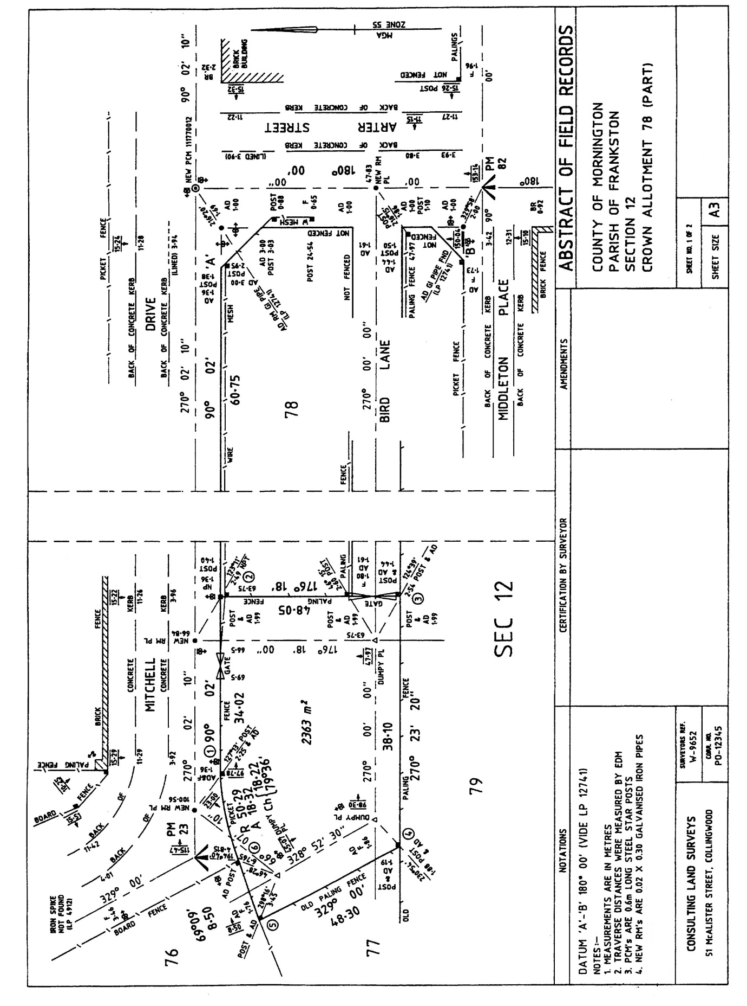

Appendix 2 – Example of alternative (non-conventional) abstract of field records

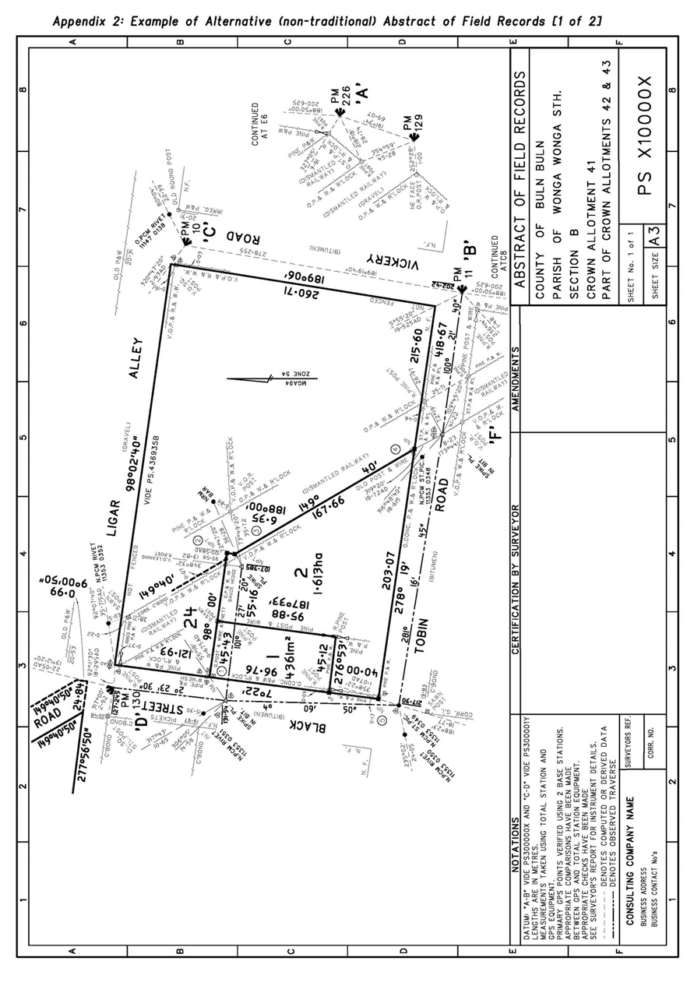

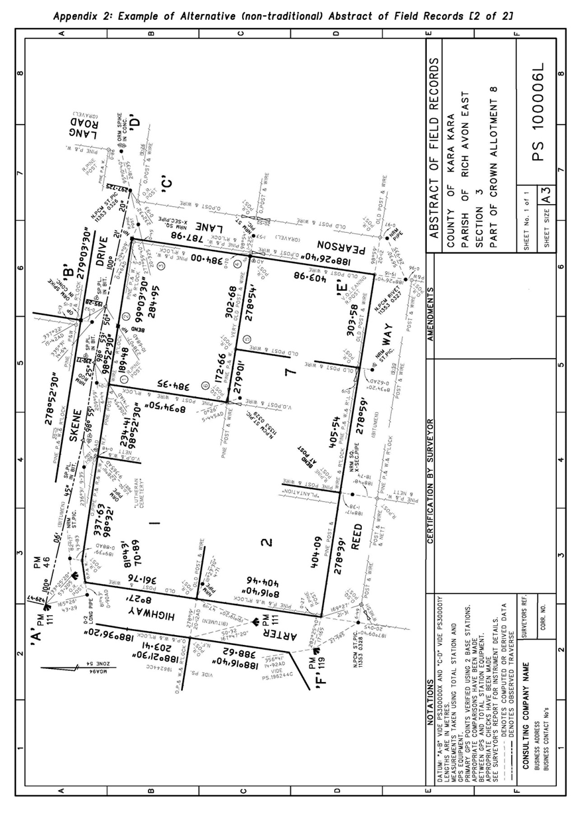

Appendix 3 – Survey documents required when lodging a plan of subdivision or consolidation

The practice of permitting some plans of subdivision and consolidation to be submitted without survey (i.e. not supported by an abstract of field records) has been updated following consultation with the surveying profession. The licensed surveyors consulted overwhelmingly concur that plans lodged at Land Victoria accompanied by complete and thorough survey documentation enhance the cadastre’s integrity and provide greater assurance that the Registrar issues ‘good title’.

It is important to note that Regulation 18 of the Subdivision (Registrar’s Requirements) Regulations 2011 requires licensed surveyors to provide a surveyor’s report and abstract of field records when a plan is lodged. There is no legislative authority that permits the lodgement and registration of plans without a current survey.

As a result of this decision, from 1 July 2016 all plans signed by a licensed surveyor must be supported by an abstract of field records unless one of the exemptions below applies.

Exemptions to providing an abstract of field records

Plans that satisfy the exemptions detailed below must still be lodged with an extensive surveyor's report prepared in accordance with these practice directives.

* Plans based on a recent survey of the property by the same surveyor or surveying firm (i.e. a survey contained in a prior plan or application).
* Plans of subdivision that do not create any new boundaries.
* Plans prepared under section 32 of the *Subdivision Act 1988* re-subdividing multi-storey buildings that only create new boundaries fully contained within the existing building.
* Plans of consolidation prepared from titles that have a clear common mathematical origin and there is no change to title dimensions. In this case, the licensed surveyor will still need to provide justification within the surveyor’s report of how the titles fit together.

Please note: Land Victoria may request survey at any time.

Partial surveys

Partial surveys that typically create one or more small lots from a significantly larger allotment (applicable primarily to rural properties) will be accepted provided that:

* the lot(s) subject to the partial survey are fully surveyed and
* only one balance lot remains, which is not subject to full survey.

All new boundaries of the lot(s) subject to the partial survey must be shown on the abstract of field records, together with sufficient information to adequately re-establish the title boundaries in which the new boundaries intersect.

Non-survey guidelines for plans lodged under Section 32 of the *Subdivision Act 1988*

An ‘addendum’ abstract of field records and licensed surveyor’s report will normally be required to support Section 32 plans, especially where a new survey was required to compute or mark new boundaries at ground level.

However, plans may be accepted without an abstract of field records if:

a) the original survey was carried out by the same surveyor or survey company within the last five years, and no additional land has been included in the plan; or

b) the new boundaries can be derived from existing information on the plan or abstract of field records without the need for further survey; or

c) the new boundaries are defined by, attached to, or contained within original buildings, and are not required to be marked at ground level.

In cases where it is doubtful if a plan will be accepted without an abstract of field records, surveyors should contact Land Victoria for advice. It is possible that an ‘addendum’ surveyor’s report could be supplied, which on its own may adequately satisfy the requirements of Land Victoria.

Where an ‘addendum’ abstract of field records and licensed surveyor’s report are supplied, they should:

a) satisfy the Surveying (Cadastral Surveys) Regulations 2015;

b) re-establish the datum of the original survey – partial surveys may be accepted; and

c) retain the bearing datum of the original plan/folio if that datum is not MGA94, i.e. the original plan/folio was not based on a survey that included a connection to marks with MGA94 coordinates.

If a connection to MGA94 is observed in the new survey, an appropriate notation should be shown on the addendum abstract of field records describing the relationship to MGA94 datum.

Appendix 4 – Land Victoria guidelines for estate subdivisions

Land Victoria, in conjunction with the Association of Consulting Surveyors Victoria (ACSV), has developed guidelines for licensed surveyors undertaking Estate Subdivisions (i.e. section 37 stage plans, super lot and large balance-lot style subdivisions). The aim of the guidelines is to:

• address deficiencies in survey documentation lodged for subsequent stages of an estate subdivision;

• remove the need for a re-survey of the balance land of an estate once the original survey has reached 5 years of age; and

• place priority on the timely provision of supplementary abstracts of field records that will become the key survey information underpinning the estate’s cadastre into the future.

This will be achieved by:

• the inclusion of more detailed information within licensed surveyor’s reports;

• the provision of ‘Plan Linking Diagrams’; and

• the lodgement of supplementary abstracts of field records on a stage-by-stage basis.

Subject to the ‘currency conditions’ of a survey being met, Land Victoria may accept enhanced survey information for estate-type subdivisions provided that;

• the location of the subject lot/stage is identified within the estate;

• the survey link to the original survey is clearly defined; and

• the abutting supplementary abstracts of field records, where applicable, have been accepted by Land Victoria and identified in the documentation.

This process will only apply to the same surveyor and survey company that attained council certification of the original plan or to a different surveyor from the same company as the originating surveyor.

A licensed surveyor may also at any time deem a new abstract of field records necessary to support a plan of subdivision of a super-lot or stage within an estate. In such cases the survey would need to be performed and documented in accordance with the current regulations and directives for cadastral surveys.

Supplementary Abstract of Field Records

a) Supplementary abstracts of field records are to be completed on a stage-by-stage basis following the completion of works in accordance with Regulation 11(5) of the Surveying (Cadastral Surveys) Regulations 2015, and must be forwarded to Land Victoria for processing. They will be stored with the survey information for the associated plan of subdivision once accepted by Land Victoria.

b) Supplementary abstracts of field records must show connections to at least three marks from the original survey or a subsequent survey that can be linked to the original survey.

Licensed surveyor’s report

Licensed surveyor’s reports for stages of an estate subdivision must provide information that;

a) Identifies the location of the subject stage within the estate;

b) Identifies the survey link between the original survey of the site and the survey of the subject stage; and

c) Identifies the location of abutting supplementary abstracts of field records that have been completed and accepted by Land Victoria.

Depending on the particular circumstance of a stage, the licensed surveyor’s report may be accompanied by ‘Plan Linking Diagrams’ to show the location of the stage in relation to the overall estate and/or the identification of abutting stages where supplementary abstracts of field records have been accepted by Land Victoria.

Examples of licensed surveyor’s reports

The following are examples of the information that is to be supplied with licensed surveyor’s reports that accompany plans of subdivision for stages of an estate;

• Example 1 – to be used for the first stage or super-lot subdivision within an estate. Only an enhanced licensed surveyor’s report is required in this instance.

• Example 2 – to be used where there are adjoining stages within an estate. An enhanced licensed surveyor’s report and Plan Linking Diagrams 1 and 2 are to be supplied.

• Example 3 – to be used for a stage remote from other stages within the estate. An enhanced licensed surveyor’s report and Plan Linking Diagram 1 are to be supplied.

Example 1

Used for the first stage of development. In most cases the subdivision process would start within 5 years of original survey registered.

LICENSED SURVEYOR’S REPORT ONLY

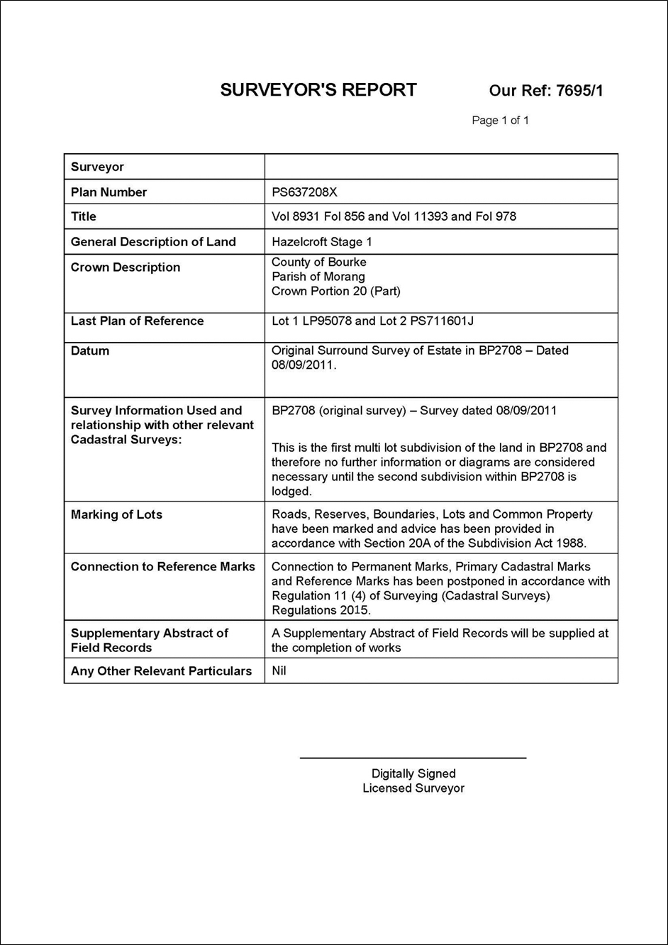

Example 2

Used to show links back to the original survey through previously supplied supplementary abstracts of field records, and to assist with the location of the land within the development.

LICENSED SURVEYOR’S REPORT

PLAN LINKING DIAGRAM 1

PLAN LINKING DIAGRAM 2

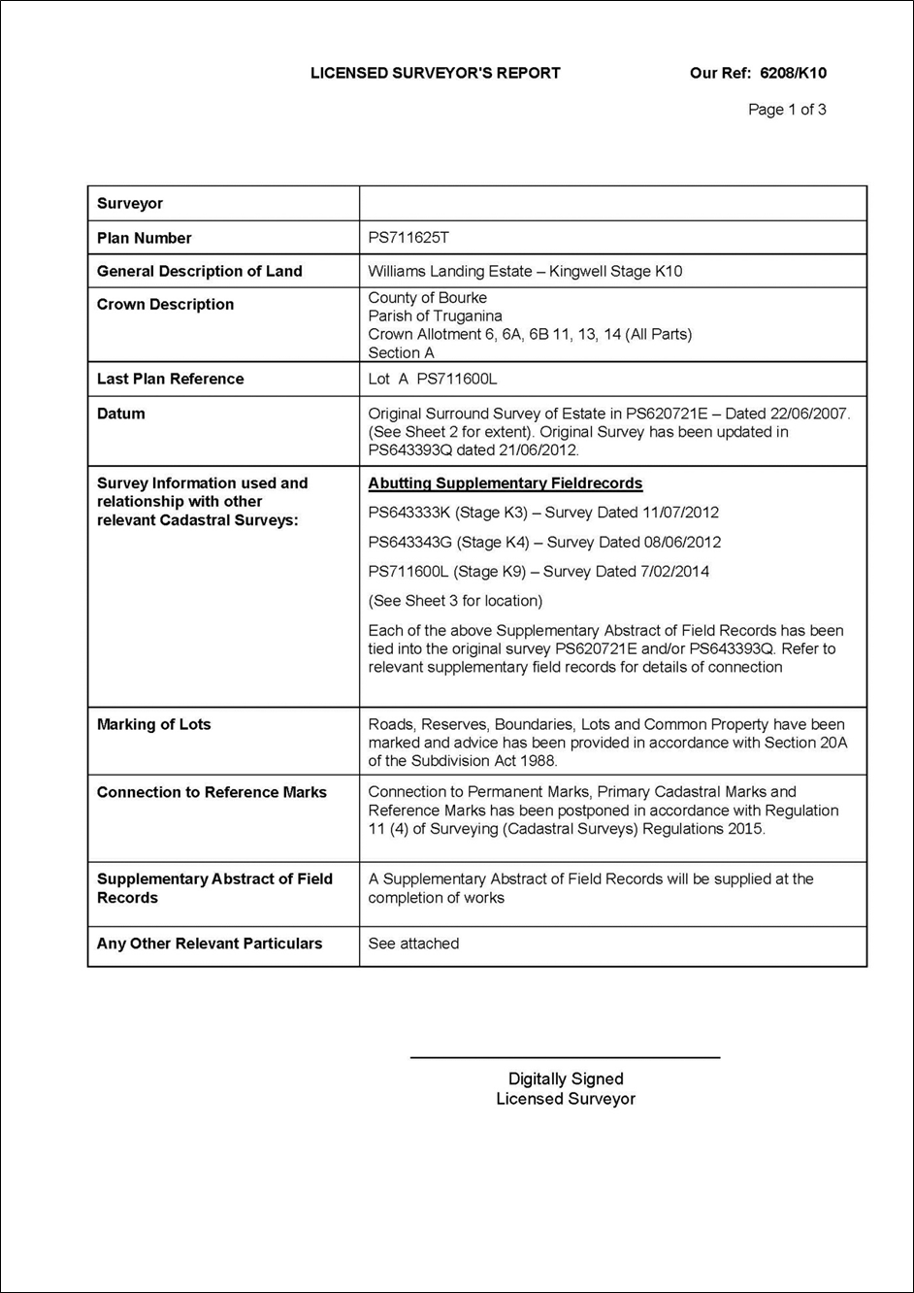

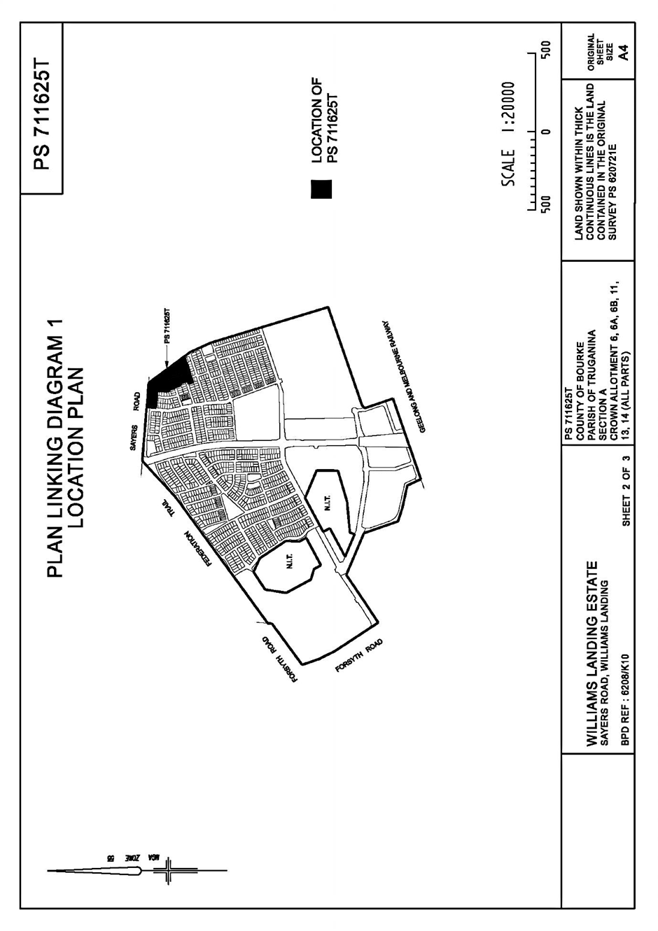

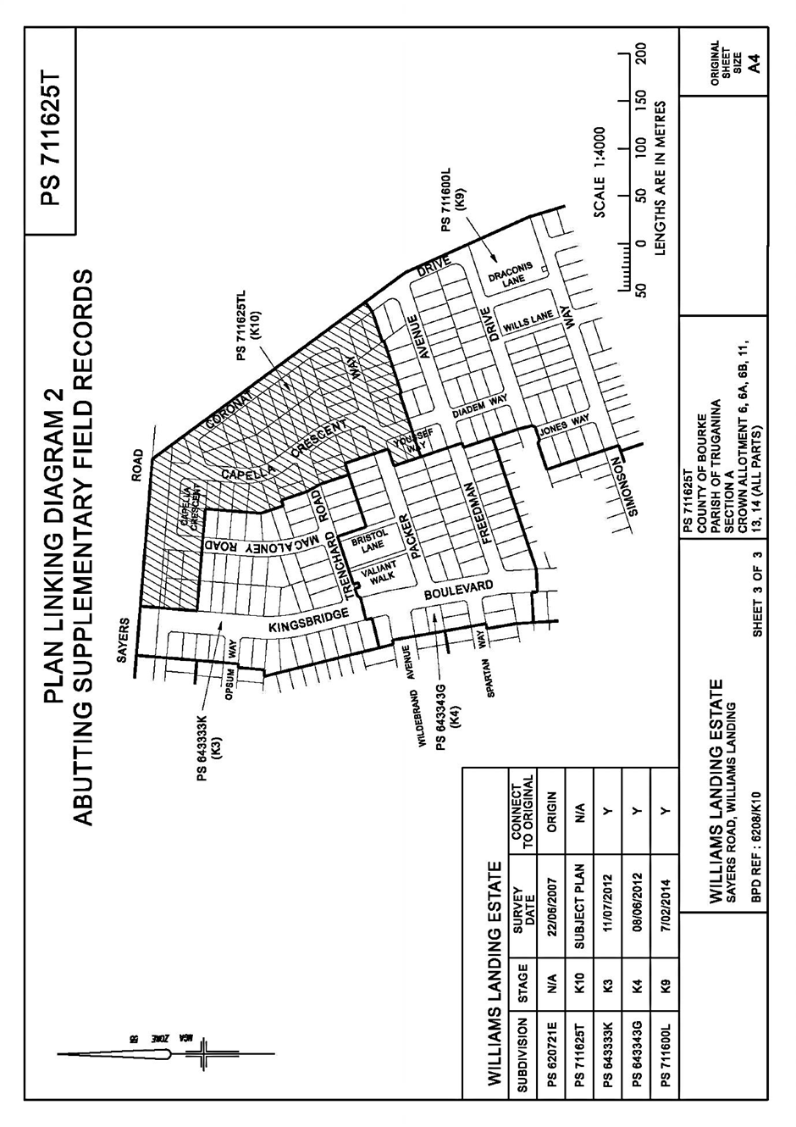

Example 3

Used for remote parcels to show the location of the subject land within the development. The report should clearly discuss links to the original survey.

LICENSED SURVEYOR’S REPORT

PLAN LINKING DIAGRAM 1

